**Individual Weekly Report**

**Name:** [**Paul Bae**](mailto:pauljwbae@gmail.com)

**Team:** Good AIM

**Date:** Mon Feb 17th

| **Current Status** |
| --- |

1. What did you **personally** work on this past week?

| **Task** | **Status** | **Time Spent** |
| --- | --- | --- |
| Database Setup | Complete | 1 Hour |
| Database Population | Complete | 3 Hours |
| Making Burndown Chart | Complete | 10 seconds |

Include **screenshots/graphics** to illustrate what you did this past week:

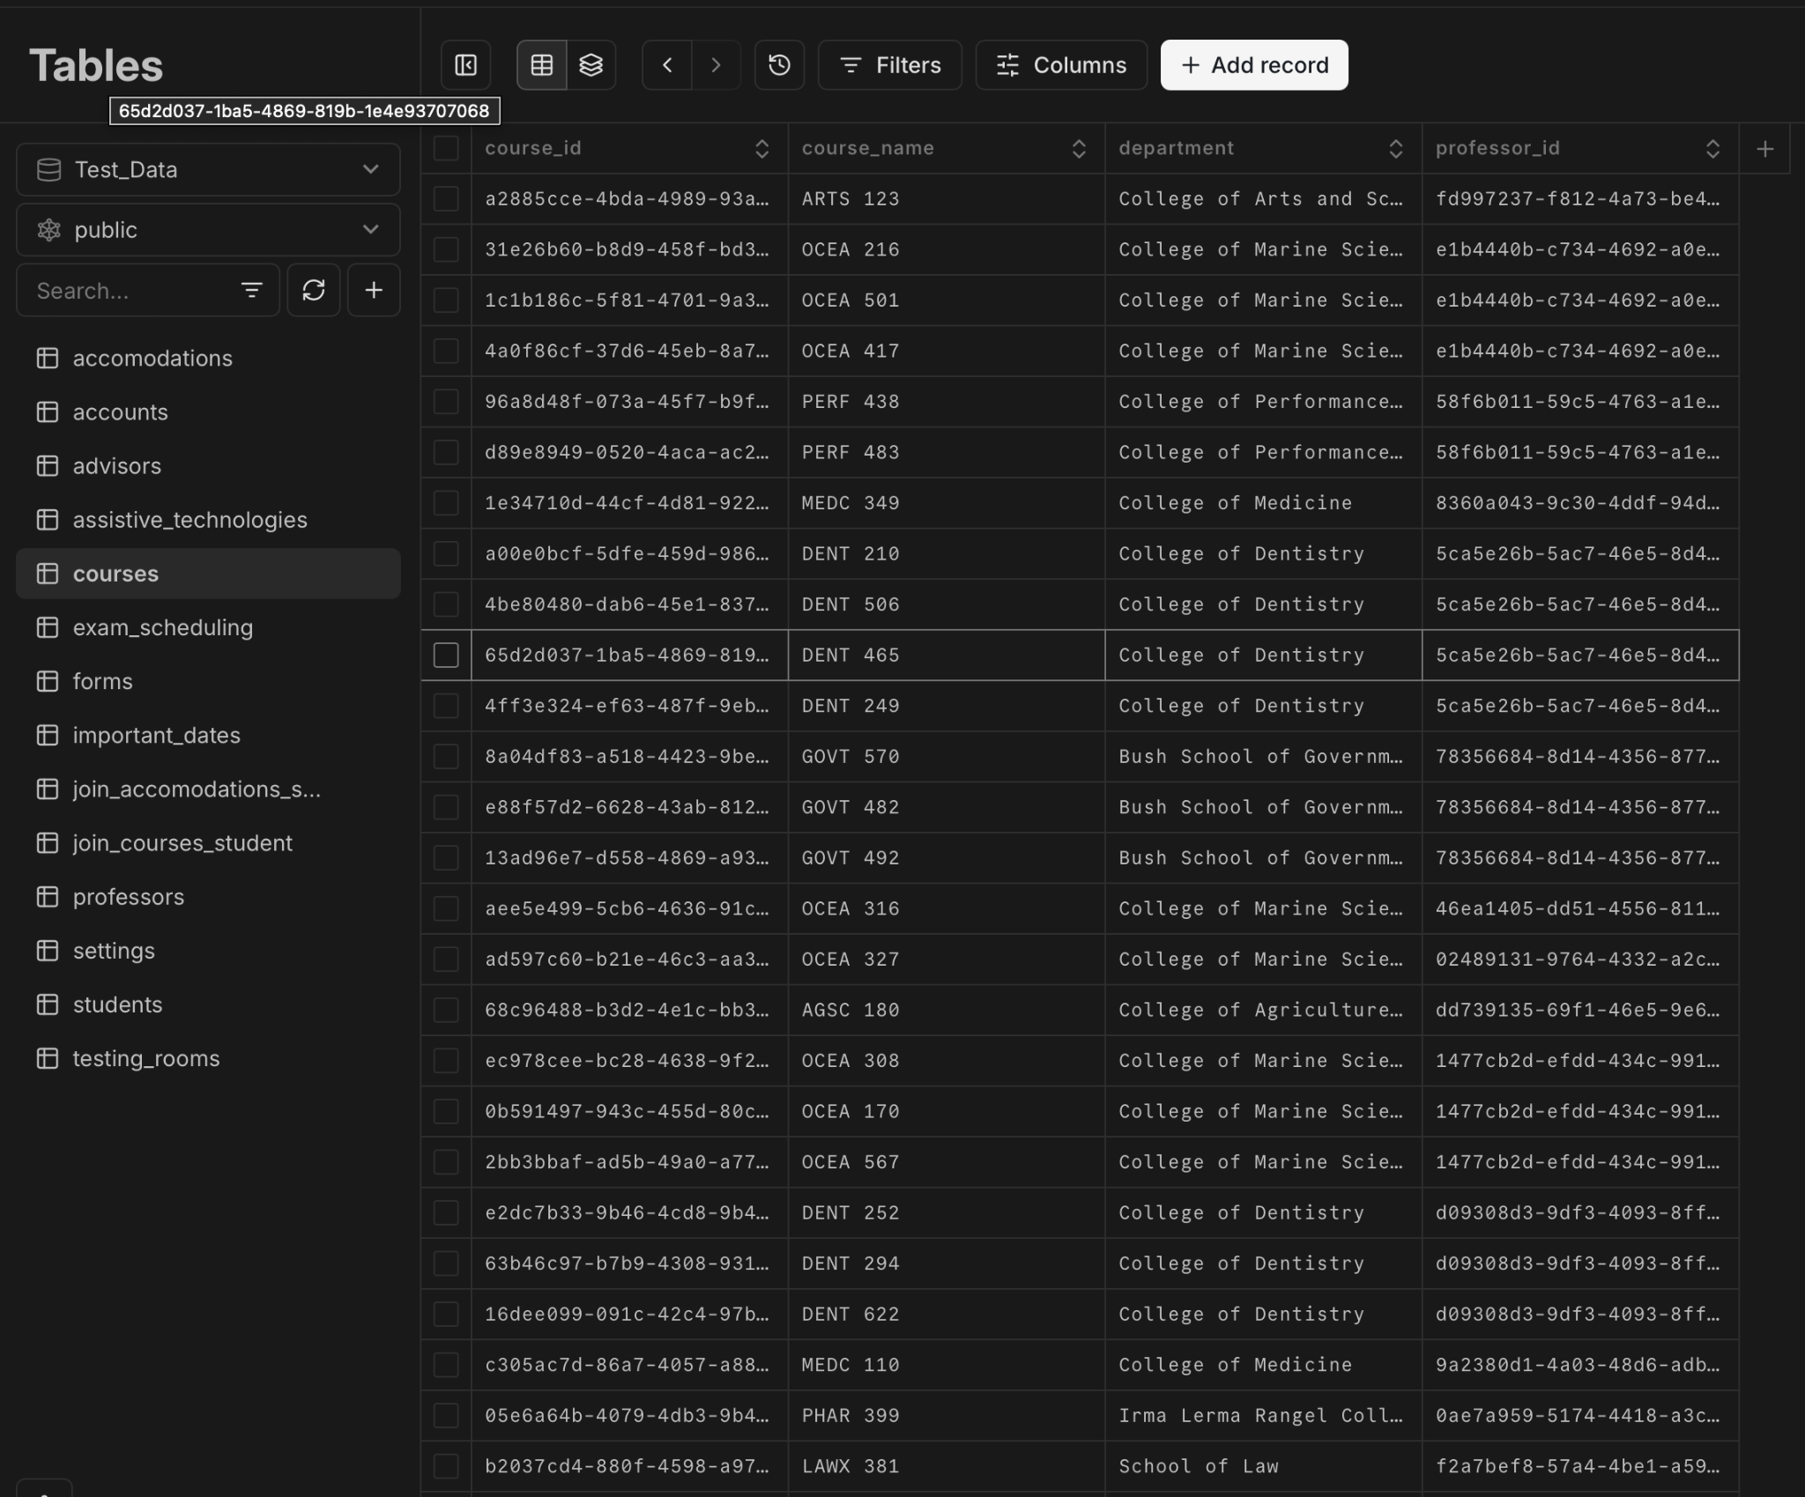

1. What problems did you run into? What is your plan for them?

I did not really come into contact with any problems this week, it was just a lot of work to slog through all of the different classes for database creation. I got through them by spending a lot of time on creating dummy data.

1. What is the current overall project status from your perspective?

The project is going as scheduled, and now that others can work on top of the database, the project should move even faster now.

1. How is your team functioning from your perspective?

The team is functioning well, we are still having difficulties with attendance, but other than that, asynchronously, we do all of the work we need to by the time we need to.

1. What new ideas did you have or skills did you develop this week?

I honed my python and Relational Database best practices knowledge this week through the large amount of python and relational table data I wrote

1. Who was your most awesome team member this week and why?

ME! I did a lot of work and put in a lot of hours to make sure that all of the data was ready by Monday at 10am!

| **Plans for Next Week** |
| --- |

What are you going to work on this next week?

I am assigned to work on the Staff view of the website, working off of the existing skeleton code that Simone created. Aside from that, I will probably work to help others on any issues they are having.